QUALITY MANUAL

QM-001
Rev. G

PROPRIETARY and CONFIDENTIAL – This document contains information, data and/or drawings which are proprietary and confidential to Skyryse, Inc. (“Skyryse”) and which are the express property of Skyryse. Except as specifically authorized in writing by an authorized signatory of Skyryse, (i) these materials are restricted to use by only Skyryse employees and other companies and persons specifically authorized in writing by Skyryse, and (ii) no portion of this document or any information contained herein shall be reproduced, disclosed, copied, furnished, reengineered in whole or in part, or used by any third party for any purpose whatsoever.

REVISION LOG
Revision | Originator | Date | Description of Change | Approval
A | Denise Gastelon | 09/26/2022 | Initial release | Denise Galstone
B | Denise Gastelon | 02/25/2023 | Format to all sections due to internal audit | Denise Galstone
C | Denise Gastelon | 03/14/2023 | Update to process diagram, section 8.5.5, format | Denise Galstone
D | Denise Gastelon | 03/20/2024 | Typo, update to management representative | Denise Galstone
E | Denise Gastelon | 04/01/2024 | Update to turtle diagrams | Denise Galstone
F | Denise Gastelon | 03/31/2025 | Reformatted, added climate change to 4.1 and 4.2, revised interaction of processes, added core process diagrams, added Accountable Manager to 5.3, added FAA Part 21 cross reference table | Denise Galstone
G | Jose Del Cid | 09/03/2026 | Full revision against AS9100D and 14 CFR Part 21 Subpart K; reduced to Level I content with detail referenced to procedures. Section 7 rewritten as a nine-stage architecture (Figure 2 replaces turtle and core process diagrams); Stage 6, Aircraft Integration and Flight Test, added. Section 12 reduced to cross-stage planning and product safety; section 8.4 removed. Quality objectives moved to stage metrics. Accountable Manager designation removed; responsibility held by VP of Product Integrity. CEO added to responsibilities; Quality Manager designated Quality Representative and OASIS point of contact. Acronyms and definitions updated. Two-year review cycle established for QMS documented information. Added section 2.1 certification basis, Appendix A compliance matrix, and Appendix B AS9100D certificate.

Table of Contents
1 PURPOSE 5
2 SCOPE 6
3 ACRONYMS/DEFINITIONS 6
4 RESPONSIBILITES 8
5 TOOLS 9
6 REFERENCED DOCUMENTS 9
7 QUALITY MANAGEMENT SYSTEM ARCHITECTURE 11
8 CONTEXT OF THE ORGANIZATION 22
9 LEADERSHIP 24
10 PLANNING 24
11 SUPPORT 25
12 OPERATION 26
13 PERFORMANCE EVALUATION 27
14 IMPROVEMENT 27
15 QUALITY POLICY AND OBJECTIVES 28
16 QUALITY RECORDS AND RETENTION 28
17 APPENDIX A: AS9100D AND 14 CFR PART 21 COMPLIANCE MATRIX 29
18 APPENDIX B: AS9100D CERTIFICATE OF REGISTRATION 31
List of Figures
Figure 1. Documentation hierarchy 11
Figure 2. Top level process flow 13
Figure 3. AS9100D certificate of registration 32
Figure 4. Certificate appendix, site specific details 33
List of Tables
Table 1. Acronyms 7
Table 2. Definitions 7
Table 3. Roles and responsibilities 9
Table 4. Tools 9
Table 5. Technical document references 10
Table 6. Industry documents 11
Table 7. Stage 1 inputs, process and outputs 14
Table 8. Stage 1 metrics 14
Table 9. Stage 2 inputs, process and outputs 15
Table 10. Stage 2 metrics 15
Table 11. Stage 3 inputs, process and outputs 16
Table 12. Stage 3 metrics 16
Table 13. Stage 4 inputs, process and outputs 17
Table 14. Stage 4 metrics 17
Table 15. Stage 5 inputs, process and outputs 17
Table 16. Stage 5 metrics 18
Table 17. Stage 6 inputs, process and outputs 18
Table 18. Stage 6 metrics 19
Table 19. Stage 7 inputs, process and outputs 19
Table 20. Stage 7 metrics 19
Table 21. Stage 8 inputs, process and outputs 20
Table 22. Stage 8 metrics 20
Table 23. Stage 9 inputs, process and outputs 21
Table 24. Stage 9 metrics 21
Table 25. Support processes 22
Table 26. Interested parties and their requirements 23
Table 27. Quality management system metrics 23
Table 28. AS9100D and 14 CFR part 21 compliance matrix 31

PURPOSE
This Quality Manual is the Level I document in the Skyryse, Inc. documentation hierarchy and describes the Skyryse Quality Management System (QMS). It states the approach taken and the responsibility assigned for each applicable requirement; it does not restate the content of the documents beneath it, and each requirement is satisfied by reference to the controlled document that carries it.
The QMS is established to meet AS9100D, Quality Management Systems, Requirements for Aviation, Space and Defense Organizations, which incorporates ISO 9001:2015, and this manual serves as the quality system description required by 14 CFR 21.308 of a Parts Manufacturer Approval applicant or holder. Appendix A maps each AS9100D clause to the section of this manual and the controlled document that address it; Appendix B maps each element of 14 CFR 21.137 to the Skyryse document that satisfies it.

SCOPE
The QMS applies to the entire business system through which Skyryse, Inc. designs, develops, produces and certifies its product and performs planned post-delivery activities. The primary product is SkyOS, a fully automated flight deck and fly-by-wire flight control system intended to reduce pilot fatigue and complexity while offering a step change in flight safety and emergency management. Within that boundary the QMS applies to all Skyryse personnel, to all externally provided processes, products and services, and to all articles produced under an FAA production approval held by Skyryse.
The QMS is more than its documented procedures and instructions. It is the combination of the people who perform the work, the tools and software systems in which the work is executed and recorded; the infrastructure, calibrated tooling, test equipment and controlled work environment used to build and verify product; the processes and their interactions; the quality records and product data generated as the work is performed; and the external providers whose processes, products and services are integrated into Skyryse product.

ACRONYMS/DEFINITIONS

Acronyms
Abbreviation | Definition
CFR | Code of Federal Regulations
FAA | Federal Aviation Administration
FOD | Foreign Object Debris or Damage
LRU | Line Replaceable Unit
OASIS | Online Aerospace Supplier Information System
PDM | Product Data Management
QMS | Quality Management System
SOP | Standard Operating Procedure
SWOT | Strengths, Weaknesses, Opportunities, Threats
TSOA | Technical Standard Order Authorization

Table 1. Acronyms

Definitions
Term | Definition
Article | A part, component, subassembly or line replaceable unit produced to an approved design.
Conformity status | The status assigned to material by Quality Assurance in accordance with P-850, being Undetermined, Conformable, Not Conformable, Fully Conformed or TSOA.
Key characteristic | A feature whose variation has a significant effect on product fit, form, function, performance, service life or producibility, and which requires specific action for control.
Product safety | The state in which a product is able to perform to its designed or intended purpose without causing an unacceptable risk of harm to persons or property.
Stage | One of the nine phases of the Skyryse product lifecycle shown in Figure 2. A stage has a single owner and defined inputs and outputs.
Critical item | An item, such as a function, part, software, characteristic or process, having significant effect on the provision and use of the product, including safety, performance, form, fit, function, producibility, service life or cost, that requires specific action to ensure it is adequately managed.
Quality escape | Nonconforming product or an article that has been released from the quality system and subsequently found not to conform to the approved design or to contractual requirements.
Stage owner | The individual accountable for a lifecycle stage, for the performance of its processes and metrics, and for the conformity of what the stage delivers to the next stage.

Table 2. Definitions

RESPONSIBILITES
Role | Responsibility
Chief Executive Officer | Provides executive leadership for the QMS and demonstrates top management commitment to it. Accountable for executive-level business operations and for providing the resources the QMS requires. Establishes and approves the Quality Policy and this manual, and confirms the Quality Policy remains aligned with the strategic direction of the organization.
Quality Manager | Management Representative and Quality Representative. Maintains this manual as a current reflection of the QMS and maintains the controlled document index. Reports QMS performance to management. Primary point of contact for the Online Aerospace Supplier Information System (OASIS) and maintains the Skyryse OASIS entry, including certification status and feedback. Has organizational freedom and unrestricted access to management to resolve quality management issues. Liaison with the registrar and with customers on QMS matters.
VP of Product Integrity | Stage owner for Certification. Responsible for and has authority over the quality system for all production operations conducted under 14 CFR part 21, and confirms that the procedures described in this manual are in place and followed. Primary contact with the FAA on matters of production approval. Chairs the Safety Review Board and approves disposition of nonconforming articles within the authority defined in P-870.
VP of Sales | Stage owner for Business Planning. Accountable for contract review and customer requirement flow down.
VP of Engineering | Stage owner for Product Development, Realization Planning, and Aircraft Integration and Flight Test. Accountable for design and development, the released configuration, production planning and flight test.
VP of Operations | Stage owner for Supply Chain, Manufacturing, Production and Post Delivery Activities. Accountable for supplier approval, purchase order content, receiving, work order execution, process control, preservation, delivery and in-service support.
VP of People and Culture | Accountable for the human resources system of record, the organizational chart, job descriptions and training records that evidence competence under P-720.
All personnel | Follow the QMS documents applicable to their work. Raise quality and product safety concerns without fear of reprisal.

Table 3. Roles and responsibilities

TOOLS
Software | Description
SolidWorks PDM | Controlled document repository and approval routing. System of record for released QMS documents and their revisions.
Jira | Work order board, Data Requirements List board, internal discrepancy and corrective action records, and supplier external portal tickets.
NetSuite | Enterprise resource planning. Purchase orders, receiving, inventory, kitting and issue to work order.
Polarion | Requirements and verification management for product development.
Git | Software configuration management and version control.
UKG | Human resources system of record. Organizational chart and training records.

Table 4. Tools
The deployed version of each tool is recorded and controlled in accordance with P-750 Control of Documented Information, and is verified at management review.

REFERENCED DOCUMENTS

Technical Document References
Type | Item ID | Description
Quality Manual | QM-001 | Quality Manual
Procedure | P-500 | Leadership Responsibility
Procedure | P-610 | Risk Management and Human Factors
Procedure | P-714 | Electrostatic Discharge Control
Procedure | P-715 | Monitoring and Measuring Resources
Procedure | P-720 | Competence, Training and Awareness
Procedure | P-750 | Control of Documented Information
Procedure | P-812 | Configuration Management
Procedure | P-814 | Counterfeit Prevention
Procedure | P-820 | Customer Related Processes
Procedure | P-830 | Design and Development
Procedure | P-840 | Supply Chain Management
Procedure | P-850 | Control of Production and Service Provision
Procedure | P-851 | FOD and 6S Control
Procedure | P-852 | Identification and Traceability
Procedure | P-853 | Property Belonging to Customers or External Providers
Procedure | P-860 | FAA Release Documents
Procedure | P-870 | Control of Nonconforming Outputs
Procedure | P-920 | Internal Audits
Procedure | P-1000 | Continual Improvement

Table 5. Technical document references

Industry Documents
Item ID | Description
AS9100D | Quality Management Systems, Requirements for Aviation, Space and Defense Organizations
ISO 9001:2015 | Quality Management Systems, Requirements
AS9102 | Aerospace First Article Inspection Requirement
14 CFR part 21 | Certification Procedures for Products and Articles
14 CFR 21.137 | Quality system
14 CFR 21.303 | Replacement and modification articles
14 CFR 21.307 | Quality system, Parts Manufacturer Approval
14 CFR 21.308 | Quality manual, Parts Manufacturer Approval
14 CFR 21.310 | Inspections and tests, Parts Manufacturer Approval
14 CFR 45.15 | Marking requirements, critical components
AC 21-43A | Production Under 14 CFR Part 21, Subparts F, G, K, and O

Table 6. Industry documents

QUALITY MANAGEMENT SYSTEM ARCHITECTURE
This section defines the architecture of the QMS: the documents that make it up, the stages of the product lifecycle, and the inputs, processes and outputs of each stage. It states what each stage is accountable for. It does not restate how the work is performed; that is defined in the procedures named in each stage.

Documentation hierarchy
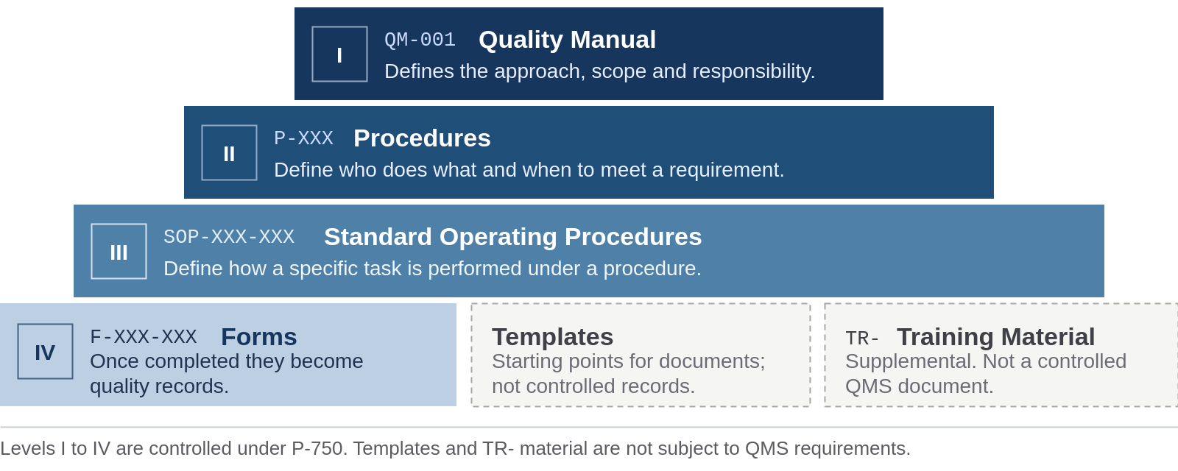
Figure 1. Documentation hierarchy
Levels I to IV are controlled in accordance with P-750 Control of Documented Information and released through SolidWorks PDM. Documents are listed in Table 5 and in the master document list maintained under P-750. Templates and TR- training material are not controlled QMS documents and are not subject to QMS requirements; no requirement of AS9100D or 14 CFR part 21 is met by TR- material alone. This manual names procedures. It names a standard operating procedure only where no procedure covers the element.

Top level process flow
The product lifecycle runs through the nine stages shown in Figure 2. Each stage has a single owner, receives defined inputs, and delivers defined outputs to the stage or stages that follow. Manufacturing delivers line replaceable units to Aircraft Integration and Flight Test and supports Certification with part and test set up conformity. Product Development releases design data to Certification for approval. Flight test findings and in-service data return to Product Development. Support processes act across all stages and are listed in section 7.12.

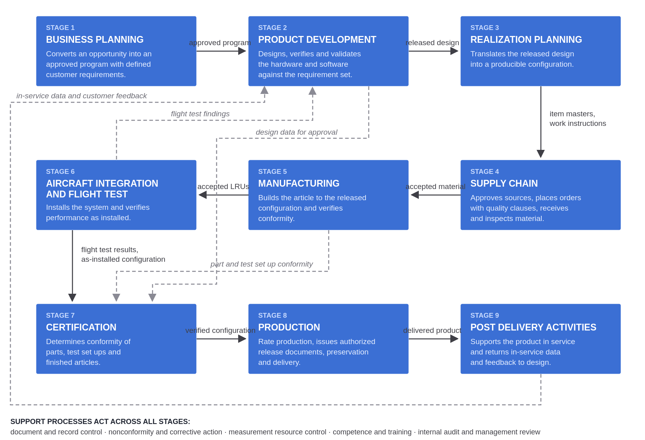
Figure 2. Top level process flow

Stage 1. Business Planning
Owner: VP of Sales. Business Planning converts an opportunity into an approved program with defined customer, statutory and regulatory requirements, and confirms that Skyryse is able to meet them before it commits.
Inputs | Process | Outputs
Customer inquiry, proposal request or program opportunity  Customer, statutory, regulatory and special requirements  Market data, in-service feedback and competitor information | Market studies  Opportunity evaluation and proposal  Contract review  Customer requirement flow down | Approved program  Reviewed and accepted contract or purchase order  Market study results  Flowed down requirement set  Contract review and risk records
Table 7. Stage 1 inputs, process and outputs
Applicable procedures. P-820 Customer Related Processes, P-610 Risk Management and Human Factors
Tools. SolidWorks PDM.
Requirements addressed. AS9100D 8.2 requirements for products and services, 8.2.2 determining requirements, 8.2.3 review of requirements. 14 CFR part 21: none applied directly at this stage.
Records and competence. The outputs listed above are quality records, controlled and retained in accordance with P-750 and section 16. Personnel performing the work of this stage are competent and, where the procedures above require it, authorized in accordance with P-720.
Metric | Target | Frequency | Source of record
Proposals and orders with a recorded contract review before acceptance | 100 percent | Monthly | Contract review records
Table 8. Stage 1 metrics

Stage 2. Product Development
Owner: VP of Engineering. Product Development designs, verifies and validates the hardware and software against the requirement set, and releases the design under configuration control.
Inputs | Process | Outputs
Approved program and requirement set  Product safety requirements  Flight test findings and in-service data  Applicable statutory and regulatory requirements | Design and development planning  Design inputs and requirements management  Design verification and validation  Design data release and change control | Released design data under configuration control  Verification and validation records  Product safety requirements traced to verification evidence  Design data released to Certification for approval
Table 9. Stage 2 inputs, process and outputs
Applicable procedures. P-830 Design and Development, P-812 Configuration Management, P-750 Control of Documented Information
Tools. Polarion, Git, SolidWorks PDM.
Requirements addressed. AS9100D 8.1.2 configuration management, 8.3 design and development. 14 CFR 21.137(a) design data control.
Records and competence. The outputs listed above are quality records, controlled and retained in accordance with P-750 and section 16. Personnel performing the work of this stage are competent and, where the procedures above require it, authorized in accordance with P-720.
Metric | Target | Frequency | Source of record
Design releases with an approved change record under configuration control | 100 percent | Monthly | Design release and change records
Table 10. Stage 2 metrics

Stage 3. Realization Planning
Owner: VP of Engineering. Realization Planning translates the released design into a producible configuration and defines where conformity will be verified.
Inputs | Process | Outputs
Released design baseline  Critical item and key characteristic candidates  Capacity, tooling and resource data | Bill of material release and make or buy  Item master and master work instruction creation  Process and tooling planning  Key characteristic and inspection planning | Released bill of material and make or buy determination  Item masters and master work instructions  Process and tooling plans  Designated critical items and key characteristics  Inspection plan
Table 11. Stage 3 inputs, process and outputs
Applicable procedures. P-812 Configuration Management, P-850 Control of Production and Service Provision, P-830 Design and Development
Tools. SolidWorks PDM, NetSuite.
Requirements addressed. AS9100D 8.1.2 configuration management, 8.1.3 product safety, 8.5.1 control of production. 14 CFR 21.137(a) design data control, (d) manufacturing process control.
Records and competence. The outputs listed above are quality records, controlled and retained in accordance with P-750 and section 16. Personnel performing the work of this stage are competent and, where the procedures above require it, authorized in accordance with P-720.
Metric | Target | Frequency | Source of record
Key characteristics from the released design present in the inspection plan | 100 percent | Monthly | Inspection plans against released design data
Table 12. Stage 3 metrics

Stage 4. Supply Chain
Owner: VP of Operations. Supply Chain approves the sources, places purchase orders with quality requirements flowed down, and accepts the material that Manufacturing builds with. Skyryse remains responsible for the conformity of all externally provided processes, products and services, including those from customer defined sources.
Inputs | Process | Outputs
Released bill of material and make or buy determination  Purchase requisitions  Supplier data and performance history | Supplier approval and approved supplier list  Purchase requisition to purchase order  Source inspection  Receiving and receiving inspection  First article inspection | Approved suppliers  Purchase orders with quality clauses flowed down  Accepted, identified and traceable material  Receiving inspection records and First Article Inspection Reports
Table 13. Stage 4 inputs, process and outputs
Applicable procedures. P-840 Supply Chain Management, P-814 Counterfeit Prevention, P-852 Identification and Traceability
Tools. NetSuite, Jira.
Requirements addressed. AS9100D 8.1.4 prevention of counterfeit parts, 8.4 control of externally provided processes, products and services. 14 CFR 21.137(c) supplier control.
Records and competence. The outputs listed above are quality records, controlled and retained in accordance with P-750 and section 16. Personnel performing the work of this stage are competent and, where the procedures above require it, authorized in accordance with P-720.
Metric | Target | Frequency | Source of record
Supplier lot acceptance rate | Greater than or equal to 90 percent | Monthly | Receiving inspection records
Supplier on time delivery | Greater than or equal to 70 percent, increasing to 90 percent by 31 December 2027 | Monthly | Purchase order promise dates against receipt dates
Table 14. Stage 4 metrics

Stage 5. Manufacturing
Owner: VP of Operations. Manufacturing builds the article to the released configuration on a released work order and verifies its conformity in process and at acceptance test. The inspection and test status of every article is identifiable at all times, and an article without an identifiable status is treated as awaiting inspection.
Inputs | Process | Outputs
Accepted material  Released work order, item masters and master work instructions  Inspection plan and key characteristics | Work order release and kitting  Assembly  In-process inspection  Acceptance testing  Handling, storage and preservation | Accepted articles and line replaceable units  Completed work order package and acceptance test results  Inspection and conformity status records  Part and test set up conformity support to Certification
Table 15. Stage 5 inputs, process and outputs
Applicable procedures. P-850 Control of Production and Service Provision, P-852 Identification and Traceability, P-851 FOD and 6S Control, P-714 Electrostatic Discharge Control
Tools. NetSuite, Jira, SolidWorks PDM.
Requirements addressed. AS9100D 8.5.1 control of production, 8.5.1.3 production process verification, 8.5.2 identification and traceability, 8.5.4 preservation. 14 CFR 21.137(d) manufacturing process control, (e) inspecting and testing, (g) inspection and test status, (j) handling and storage.
Records and competence. The outputs listed above are quality records, controlled and retained in accordance with P-750 and section 16. Personnel performing the work of this stage are competent and, where the procedures above require it, authorized in accordance with P-720. Inspection and test personnel are qualified for the inspections they perform.
Metric | Target | Frequency | Source of record
First pass yield at in process inspection | Greater than or equal to 90 percent | Monthly | Inspection and nonconformance records against work orders
Table 16. Stage 5 metrics

Stage 6. Aircraft Integration and Flight Test
Owner: VP of Engineering. Aircraft Integration and Flight Test installs the product on the aircraft and verifies its performance in the installed configuration.
Inputs | Process | Outputs
Accepted line replaceable units  Approved installation configuration  Approved flight test plan | Line replaceable unit receipt and aircraft installation  Hangar maintenance  Flight test execution | Installed and recorded as-installed configuration  Flight test report  Flight test findings returned to Product Development
Table 17. Stage 6 inputs, process and outputs
Applicable procedures. P-830 Design and Development, P-850 Control of Production and Service Provision, P-852 Identification and Traceability
Tools. Jira, Polarion.
Requirements addressed. AS9100D 8.5.1 control of production, 8.6 release of products and services. 14 CFR 21.137(e)(1) flight test of each aircraft produced.
Records and competence. The outputs listed above are quality records, controlled and retained in accordance with P-750 and section 16. Personnel performing the work of this stage are competent and, where the procedures above require it, authorized in accordance with P-720.
Metric | Target | Frequency | Source of record
Discrepancies affecting airworthiness open at flight release | Zero | Each flight release, from the first flight release | Flight release and flight test records
Table 18. Stage 6 metrics

Stage 7. Certification
Owner: VP of Product Integrity. Certification establishes the conformity of parts, test set ups and finished articles, and verifies the configuration against the released design before the product is released to rate production.
Inputs | Process | Outputs
Released design data  Part and test set up conformity support from Manufacturing  Flight test results and as-installed configuration | Part conformity  Test set up conformity  Final inspection and conformity determination | Conformity records  Verified configuration released to Production
Table 19. Stage 7 inputs, process and outputs
Applicable procedures. P-812 Configuration Management, P-850 Control of Production and Service Provision
Tools. SolidWorks PDM, Jira.
Requirements addressed. AS9100D 8.6 release of products and services. 14 CFR 21.137(e) inspecting and testing.
Records and competence. The outputs listed above are quality records, controlled and retained in accordance with P-750 and section 16. Personnel performing the work of this stage are competent and, where the procedures above require it, authorized in accordance with P-720.
Metric | Target | Frequency | Source of record
Conformity inspections accepted at first presentation | Baseline established over the first three packages, target set at the following management review | Each conformity package | Conformity inspection records
Table 20. Stage 7 metrics

Stage 8. Production
Owner: VP of Operations. Production produces the released configuration at rate, issues the authorized release documents, and delivers the product to the customer with its conformity preserved.
Inputs | Process | Outputs
Released and verified configuration  Customer orders and delivery requirements  Packaging specifications flowed down by the customer | Rate production process control  Issue of authorized release documents  Packaging  Shipping | Delivered product  Certificate of Conformance and FAA Form 8130-3  Shipping and packaging records  Process performance data
Table 21. Stage 8 inputs, process and outputs
Applicable procedures. P-850 Control of Production and Service Provision, P-860 FAA Release Documents, P-852 Identification and Traceability, P-851 FOD and 6S Control, P-853 Property Belonging to Customers or External Providers
Tools. NetSuite, Jira, SolidWorks PDM.
Requirements addressed. AS9100D 8.5.1 control of production, 8.5.3 property belonging to customers or external providers, 8.5.4 preservation, 8.5.6 control of changes, 8.6 release of products and services. 14 CFR 21.137(d) manufacturing process control, (j) handling and storage, (o) issuing authorized release documents; 14 CFR 21.303 replacement and modification articles.
Records and competence. The outputs listed above are quality records, controlled and retained in accordance with P-750 and section 16. Personnel performing the work of this stage are competent and, where the procedures above require it, authorized in accordance with P-720. Authorized release documents are issued only by individuals authorized under P-860.

Metric | Target | Frequency | Source of record
Customer on time delivery | Greater than or equal to 90 percent | Monthly, from the first delivery | Shipment records against customer promise dates
Delivered product conformity, units accepted without customer rejection | Greater than or equal to 98 percent | Monthly, from the first delivery | Customer rejection and escape records
Table 22. Stage 8 metrics

Stage 9. Post Delivery Activities
Owner: VP of Operations. Post Delivery Activities supports the product in service and returns what is learned to Product Development. Quality escapes are notified to affected customers and, where applicable, to the FAA, within the timescales stated in section 11.4.
Inputs | Process | Outputs
Delivered product  Customer feedback and in-service data  Returned material and escape notifications | In-service feedback and return material authorization  Quality escape handling and customer notification  Support to the design approval holder on in-service problems | In-service data and feedback to Product Development  Return material authorization records  Customer and FAA notifications  Corrective actions
Table 23. Stage 9 inputs, process and outputs
Applicable procedures. P-820 Customer Related Processes, P-830 Design and Development, P-870 Control of Nonconforming Outputs, P-1000 Continual Improvement
Tools. Jira, NetSuite.
Requirements addressed. AS9100D 8.5.5 post-delivery activities, 10.2 nonconformity and corrective action. 14 CFR 21.137(m) in-service feedback, (n) quality escapes.
Records and competence. The outputs listed above are quality records, controlled and retained in accordance with P-750 and section 16. Personnel performing the work of this stage are competent and, where the procedures above require it, authorized in accordance with P-720.
Metric | Target | Frequency | Source of record
Regulatory reports and customer notifications of a quality escape made within the required window | 100 percent | Each event, from the first delivery | Quality escape and regulatory reporting records
Table 24. Stage 9 metrics

Support processes
Support processes are not part of the lifecycle sequence. They supply inputs to, and receive outputs from, every stage.
Support process | Applicable procedures
Document and record control | P-750 Control of Documented Information
Nonconformity, Material Review Board and corrective action | P-870 Control of Nonconforming Outputs, P-1000 Continual Improvement
Measurement resource control | P-715 Monitoring and Measuring Resources
Competence, training and awareness | P-720 Competence, Training and Awareness
Internal audit and management review | P-920 Internal Audits, P-500 Leadership Responsibility
Table 25. Support processes
Tools. SolidWorks PDM, Jira, UKG.
Requirements addressed. AS9100D 7.1.5 monitoring and measuring resources, 7.2 competence, 7.5 documented information, 8.7 control of nonconforming outputs, 9.2 internal audit, 9.3 management review, 10.2 nonconformity and corrective action. 14 CFR 21.137(b) document control, (f) inspection, measuring and test equipment control, (h) nonconforming product and article control, (i) corrective and preventive actions, (k) control of quality records, (l) internal audits.
A nonconforming article is identified, segregated and dispositioned by the Material Review Board under P-870. Disposition is made only by individuals authorized under P-870, and scrap is positively controlled until it has been rendered unusable. Nonconformance data is analyzed for trend and reviewed at management review.

Interaction of processes
Figure 2 shows the sequence of the stages and the flows between them. The stage tables in sections 7.3 to 7.11 state the inputs each stage receives and the outputs it delivers, and the output of one stage is the input of the next. The procedures named in each stage state the controls, responsibilities and measures of the work. Together these determine the processes of the QMS, their sequence and their interaction, as required by AS9100D 4.4.

CONTEXT OF THE ORGANIZATION
This section addresses AS9100D clause 4.

Understanding the organization and its context
Skyryse determines the external and internal issues relevant to its ability to achieve the intended results of the QMS through the Quality Policy, the mission and values statements, the scope in section 2, the process architecture in section 7, SWOT and process analysis performed in accordance with P-610, and discussion at board meetings and management review.
Skyryse has assessed whether climate change is a relevant issue to the QMS through a review of customer contracts and applicable regulatory requirements. The results are documented through risk analysis under P-610, are recorded in Table 26, and are reviewed periodically at management review.

Needs and expectations of interested parties
Interested party | Determination of requirements
Customers | Products and services meeting agreed quality and delivery requirements, and responsive communication. Determined and controlled under P-820. Performance is monitored at management review. Climate change requirements relevant to the QMS: none at this time.
Suppliers | Clear communication of requirements and timely payment. Controlled under P-840, which flows quality requirements down through the purchase order and maintains the approved supplier list. Climate change requirements relevant to the QMS: none at this time.
FAA | Compliance with 14 CFR part 21. Skyryse holds or is applying for approval under subpart K, Parts Manufacturer Approval. The quality system required by 21.307 is described in this manual as required by 21.308, and each element of 21.137 is mapped to the document that satisfies it in Appendix A. Authorized release documents are issued in accordance with P-860. Skyryse allows the FAA to inspect its quality system, facilities, technical data and articles, and to witness tests, including at supplier facilities, as required by 21.310.
Other U.S. regulatory and legal authorities | Compliance with applicable legal requirements. ITAR, DFAR and FAR apply on a case by case basis when applied to a contract or purchase order by the customer. When applied, the governing regulatory body is an interested party.
Employees | Fair treatment and clear communication. Encouraged to provide feedback and recommendations for improvement, and to raise product safety concerns without fear of reprisal.
Investors | The continued success of Skyryse.
Table 26. Interested parties and their requirements

Determining the scope of the QMS
The scope of the QMS is determined in section 2 of this manual and is illustrated by the top level process flow in Figure 2.

LEADERSHIP
This section addresses AS9100D clause 5.

Leadership and commitment
Management has developed and implemented P-500 Leadership Responsibility. Management approves this manual, holds management review, performs risk analysis under P-610 and ensures applicable information is communicated to personnel. Commitment is demonstrated through the Quality Policy, the quality objectives and the process measures in section 15.
Applicable customer and legal requirements are identified and met in accordance with P-820. Risks that can affect meeting customer requirements are assessed during contract review. Objectives are defined and used to maintain acceptable performance in product conformity and on time delivery.

Policy
The Quality Policy is stated in section 15 of this manual. It is posted at all Skyryse locations, is communicated to all personnel, and is shared with new personnel during orientation.

Organizational roles, responsibilities and authorities
Roles, responsibilities and authorities are stated in section 4 of this manual and are further defined in the organizational chart maintained in UKG, in job descriptions, and in the procedures.
The Quality Manager is appointed as the Management Representative, with responsibility for ensuring the QMS conforms to AS9100D, that processes deliver their intended outputs, and that the integrity of the QMS is maintained when changes are planned and implemented, and with the organizational freedom and unrestricted access to management necessary to resolve quality management issues.

PLANNING
This section addresses AS9100D clause 6.

Actions to address risks and opportunities
Risk is addressed through SWOT and process analysis as described in P-610 Risk Management and Human Factors. Operational risk within a lifecycle stage is addressed in the procedure governing that stage.

Quality objectives and planning to achieve them
Quality objectives are the metrics stated in the stage sections of section 7. When a target is not achieved for three consecutive months, or on the twelve month average, the data is communicated to management and a corrective action is raised and managed under P-1000 Continual Improvement.
Each objective states in its table the target, the frequency at which it is reported and the source of record from which it is reported. Where a table states that a metric is reported from the first flight release or from the first delivery, the objective is dormant until that condition is met. A dormant objective is reported at management review as not yet active and is not treated as a target that has not been achieved. The stage owner declares the objective active when the condition is met. Where a target is stated as a baseline, the baseline is established over the first three reporting periods after activation and the target is set at the following management review; those periods are not counted toward the three consecutive months above.

Planning of changes
Changes that could affect the QMS are reviewed and recorded at management review under P-500.

SUPPORT
This section addresses AS9100D clause 7.

Resources
Management provides the resources necessary to maintain the QMS. Resource needs are identified through risk and process analysis, internal audit, contract review and management review. Personnel needs are determined through the organizational chart and job descriptions. Infrastructure is maintained through preventive and routine maintenance.
Where product conformity can be affected, Skyryse monitors and controls environmental factors including temperature, humidity and light. Human factors are assessed in accordance with P-610. Electrostatic discharge is controlled in accordance with P-714.
Monitoring and measuring resources, including measurement traceability, are controlled in accordance with P-715. Each calibration standard is traceable to a standard acceptable to the FAA. Equipment found out of calibration triggers a review of the validity of previous measurements and of the articles accepted on the basis of them.
Organizational knowledge is documented in the procedures, standard operating procedures, the training matrix and job descriptions, and is updated under P-1000 when changes to the system warrant it.

Competence
Skyryse determines the competence required for each role, ensures that personnel are competent on the basis of appropriate education, training or experience, acts where a gap exists, evaluates the effectiveness of that action and retains evidence of competence, in accordance with P-720 Competence, Training and Awareness. The competence and any authorization required within a lifecycle stage are stated in that stage section and in the procedures named there.
Evidence of competence is retained for all personnel whose work affects QMS performance, without exception for length of service.

Awareness
All personnel are made aware of the Quality Policy, the quality objectives, their contribution to the effectiveness of the QMS and to product and service conformity, their contribution to product safety, the implications of not conforming with QMS requirements, and the importance of ethical behavior. Initial awareness training is delivered within the first ninety days of employment and is recorded under P-720.

Communication
Internal communication of QMS effectiveness is through team and management meetings, management review, internal audit closing meetings, all-hands meetings and email.
External communication with the FAA on matters of production approval is through the VP of Product Integrity. Communication with other regulatory authorities and with external parties on QMS matters is through the Quality Manager. Communication with customers regarding orders and feedback is in accordance with P-820.
Skyryse provides right of access for its customers, its customers’ customers, and statutory and regulatory authorities to the applicable areas of all facilities, at any level of the supply chain involved in the order, and to all applicable records.
Changes that may affect quality, product fit, form or function, or delivery are communicated in writing to affected customers and applicable regulatory agencies before the change is incorporated. Such changes include company ownership, company name, top management, manufacturing facility location and quality approvals. Where required, customer approval is obtained before the change takes effect.
A change in the status of AS9100D certification is notified to customers within two business days of receiving notification from the registrar. A quality escape, meaning nonconforming product that has shipped, is notified to affected customers within forty-eight to seventy-two hours of discovery and is handled in accordance with P-870.

Documented information
Documented information is created, updated and controlled in accordance with P-750 Control of Documented Information. SolidWorks PDM is the system of record for released QMS documents and their revisions, and the controlled index of QMS documents and quality records is maintained under P-750. QMS documented information and the quality records it generates shall be reviewed during regular use and internal audits. The review is recorded under P-750 and its results are reported at management review.

OPERATION
This section addresses AS9100D clause 8. The work of clause 8 is performed within the lifecycle stages in section 7 and is mapped in Appendix A. This section states only the planning that applies before and across those stages. Operational planning and control is performed before the release of new products and processes and establishes process criteria, product acceptance criteria, design verification and process control, including controls for critical items and key characteristics and for the temporary or permanent transfer of work. Planning considers personal and product safety, producibility and inspection, reliability, availability and maintainability, suitability of parts and materials, embedded software, product obsolescence, FOD prevention and detection, preservation, and final disposition at end of life.

Product safety
Product safety is planned and controlled across the lifecycle rather than in a single activity. Product safety requirements are design inputs in stage 2 and are traced to verification evidence. Hazards and their risk are assessed under P-610. Features whose variation affects safety are designated as critical items or key characteristics in stage 3 and are placed under configuration control. Counterfeit parts are prevented under P-814. Personnel are made aware of their contribution to product safety under P-720 and may raise a product safety concern without fear of reprisal. A nonconformity assessed as affecting product safety is escalated to the Safety Review Board and to the VP of Product Integrity.

PERFORMANCE EVALUATION
This section addresses AS9100D clause 9.

Monitoring, measurement, analysis and evaluation
Each stage is monitored against the metrics stated in its stage section. Metric performance, customer satisfaction measured through customer feedback under P-820, the performance of external providers, the effectiveness of actions taken to address risks and opportunities, and the need for improvement are analyzed and evaluated at management review under P-500. Where a target is not achieved as described in section 10.2, a corrective action is raised under P-1000. Internal audit measures the conformity of the QMS itself rather than the performance of a stage and is described in section 13.2.
The metrics in Table 27 measure the quality management system itself rather than a single stage. They are reported at management review on the frequency stated and are subject to section 6.2.
Metric | Target | Frequency | Source of record
Internal audits performed against the audit plan | 100 percent of audits planned | Annually | Internal audit schedule and audit reports
Audit findings and corrective actions closed by the committed date | Greater than or equal to 90 percent | Semi-Annually | Corrective action records
Table 27. Quality management system metrics

Internal audit
Internal audits are planned, conducted and documented in accordance with P-920 Internal Audits. The audit program covers every clause of AS9100D and every element of 14 CFR 21.137 across the audit cycle. Audit results are reported to the manager responsible for implementing corrective and preventive action in the area audited, and findings are managed through P-1000.

Management review
Management review is performed in accordance with P-500 Leadership Responsibility. Outputs are recorded and tracked to closure under P-1000.

IMPROVEMENT
This section addresses AS9100D clause 10.
Improvement projects arise from risk and process analysis, from corrective actions resulting from nonconformities and opportunities identified in internal audit, from internal and customer corrective actions, and from management review.
Nonconformity and corrective action, including the identification, analysis and correction of the causes of actual or potential nonconformity to the approved design or noncompliance with the approved quality system, is performed in accordance with P-1000 Continual Improvement. Continual improvement is performed in accordance with P-1000.
Quality escapes, meaning product released from the quality system and subsequently found not to conform, are identified, analyzed and corrected in accordance with P-870 and P-1000, and are notified to affected customers and, where applicable, to the FAA, as described in section 11.4.

QUALITY POLICY AND OBJECTIVES

Quality Policy
Skyryse and its employees are committed to meeting customer and legal requirements in order to achieve customer satisfaction. We will strive to provide quality products on time and continually improve our Quality Management System.

Mission
Skyryse wants to empower anyone to fly anywhere, in any aircraft, safely and as a highly experienced pilot would. SkyOS brings advanced automation to flight controls and flight management systems to achieve unmatched safety and greatly reduce opportunities for human error.

Quality objectives and process measures
Quality objectives are the metrics stated in the stage sections of section 7. Each is owned by the stage owner, is reviewed at management review, and is subject to corrective action under P-1000 when its target is not achieved as described in section 10.2.
The activation and baseline provisions of section 6.2 apply. The metrics in section 13.1 measure the quality management system itself and are owned by the Quality Manager.

QUALITY RECORDS AND RETENTION
Record are identified, stored, protected, retrieved, and retained in accordance with P-750 Control of Documented Information. Records generated during each stage, as defined in that stage's respective section, provide objective evidence that all requirements have been met and that articles conform to approved design data. The physical location, minimum retention period, and final disposition of these records are also controlled under P-750.

APPENDIX A: AS9100D AND 14 CFR PART 21 COMPLIANCE MATRIX
Skyryse is an applicant for or holder of a Parts Manufacturer Approval under 14 CFR part 21 subpart K. The quality system required by 21.307 is described in this manual as required by 21.308. Replacement and modification articles under 21.303 are released in accordance with P-860, and the right of the FAA to inspect and witness tests under 21.310 is stated in section 11.4. The table below maps each requirement of AS9100D, and each element of 21.137 that it satisfies, to the Skyryse document that meets it. The AS9100D certificate of registration is reproduced in Appendix B.
AS9100D clause | 14 CFR 21.137 element | QMS document
4 Context of the organization | N/A | QM-001 §8
5 Leadership | N/A | QM-001 §9, P-500
6.1 Risks and opportunities | N/A | P-610
6.2 Quality objectives | N/A | QM-001 §15
6.3 Planning of changes | N/A | QM-001 §10.3
7.1.5 Monitoring and measuring resources | (f) Inspection, measuring, and test equipment control | P-715
7.1.6 Organizational knowledge | N/A | QM-001 §11.1
7.2 Competence | N/A | P-720, QM-001 §11.2
7.3 Awareness | N/A | P-720, QM-001 §11.3
7.5 Documented information | (b) Document control  (k) Control of quality records | P-750, QM-001 §11.5, §16
8.1 Operational planning and control | N/A | QM-001 §12
8.1.1 Operational risk management | N/A | P-610
8.1.2 Configuration management | (a) Design data control | P-812, P-750, QM-001 §7.4
8.1.3 Product safety | N/A | QM-001 §12.1, P-830, P-610, P-812, P-814
8.1.4 Prevention of counterfeit parts | N/A | P-814, QM-001 §7.6
8.2 Requirements for products and services | N/A | P-820, QM-001 §7.3
8.3 Design and development | (a) Design data control | P-830, P-812, QM-001 §7.4
8.4 Externally provided processes | (c) Supplier control | P-840, P-814, QM-001 §7.6
8.5.1 Control of production | (d) Manufacturing process control  (e) Inspecting and testing | P-850, QM-001 §7.7, §7.10
8.5.1.3 Production process verification | (e) Inspecting and testing | P-850, SOP-850-005
8.5.2 Identification and traceability | (g) Inspection and test status | P-852, QM-001 §7.7
8.5.3 Property of customers or providers | N/A | P-853, QM-001 §7.10
8.5.4 Preservation | (j) Handling and storage | P-852, P-851, QM-001 §7.7
8.5.5 Post-delivery activities | (m) In-service feedback | P-820, P-830, QM-001 §7.11
8.5.6 Control of changes | N/A | P-850, P-820, QM-001 §7.11
8.6 Release of products and services | (e) Inspecting and testing  (o) Issuing authorized release documents | P-850, P-860, QM-001 §7.9, §7.10
8.7 Control of nonconforming outputs | (h) Nonconforming product and article control | P-870, QM-001 §7.12
9.1 Monitoring and measurement | N/A | QM-001 §13.1, P-500
9.2 Internal audit | (l) Internal audits | P-920
9.3 Management review | N/A | P-500
10.2 Nonconformity and corrective action | (i) Corrective and preventive actions  (n) Quality escapes | P-1000, P-870
10.3 Continual improvement | N/A | P-1000
Table 28. AS9100D and 14 CFR part 21 compliance matrix

APPENDIX B: AS9100D CERTIFICATE OF REGISTRATION
The certificate of registration issued by Perry Johnson Registrars, Inc. is reproduced below. Page 2 lists the sites covered by the campus scheme. The certificate is valid only while surveillance is maintained; a change in its status is notified to customers in accordance with section 11.4.
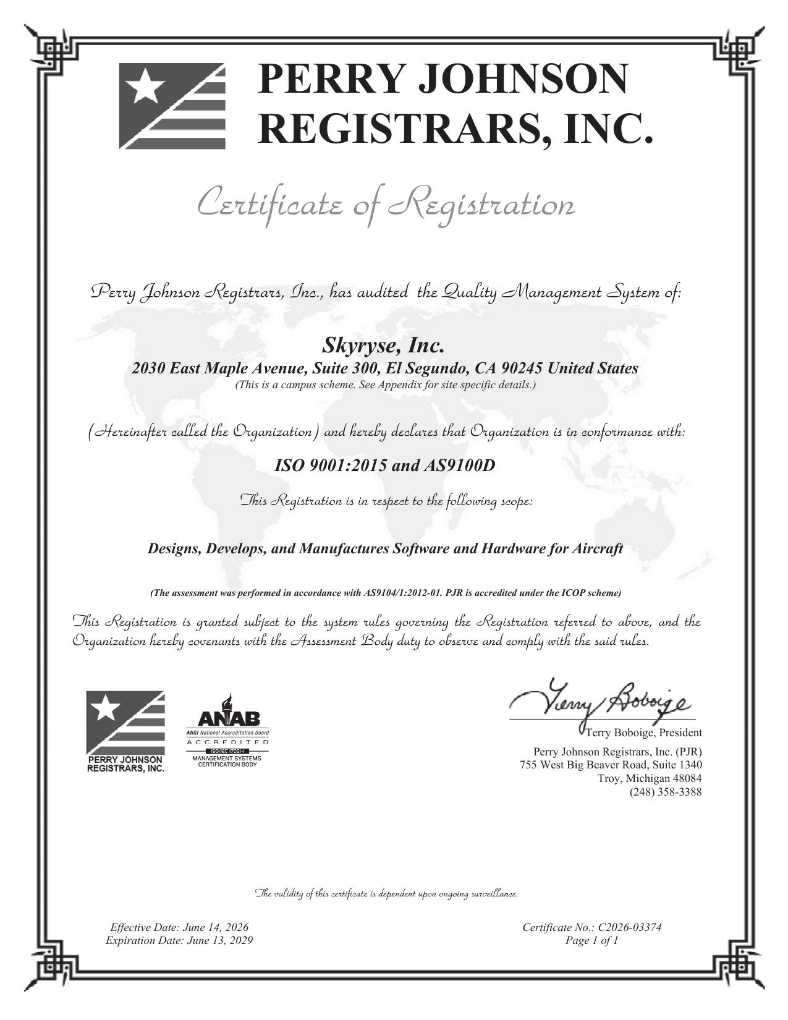
Figure 3. AS9100D certificate of registration
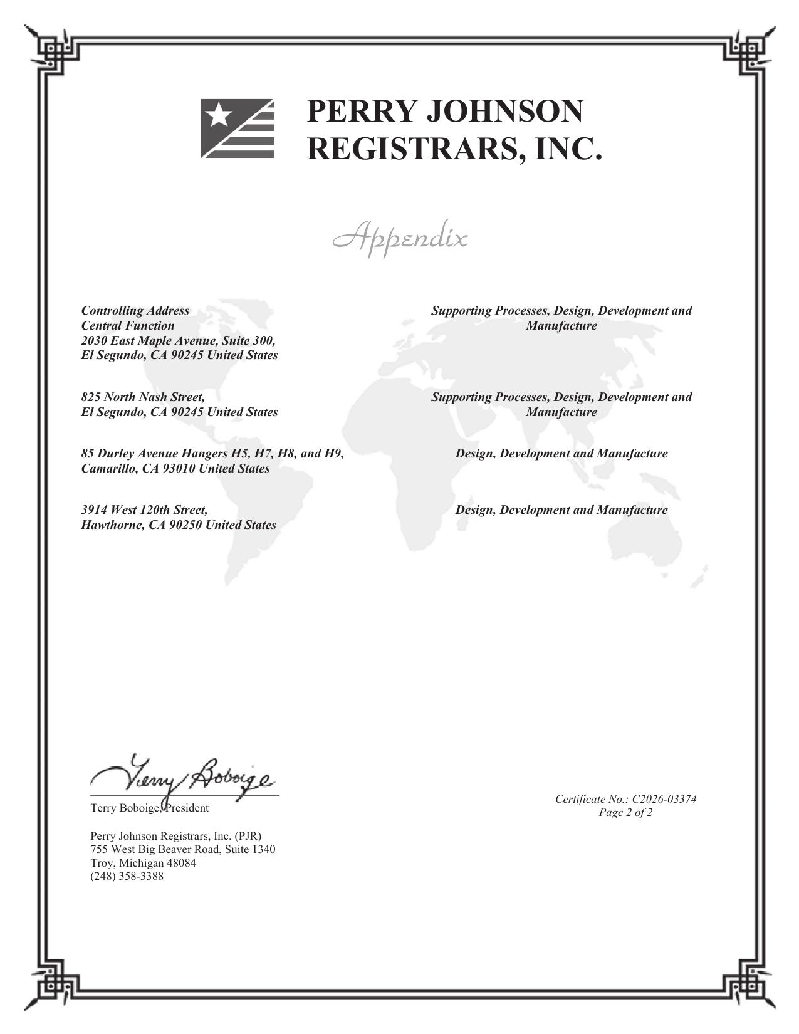
Figure 4. Certificate appendix, site specific details

